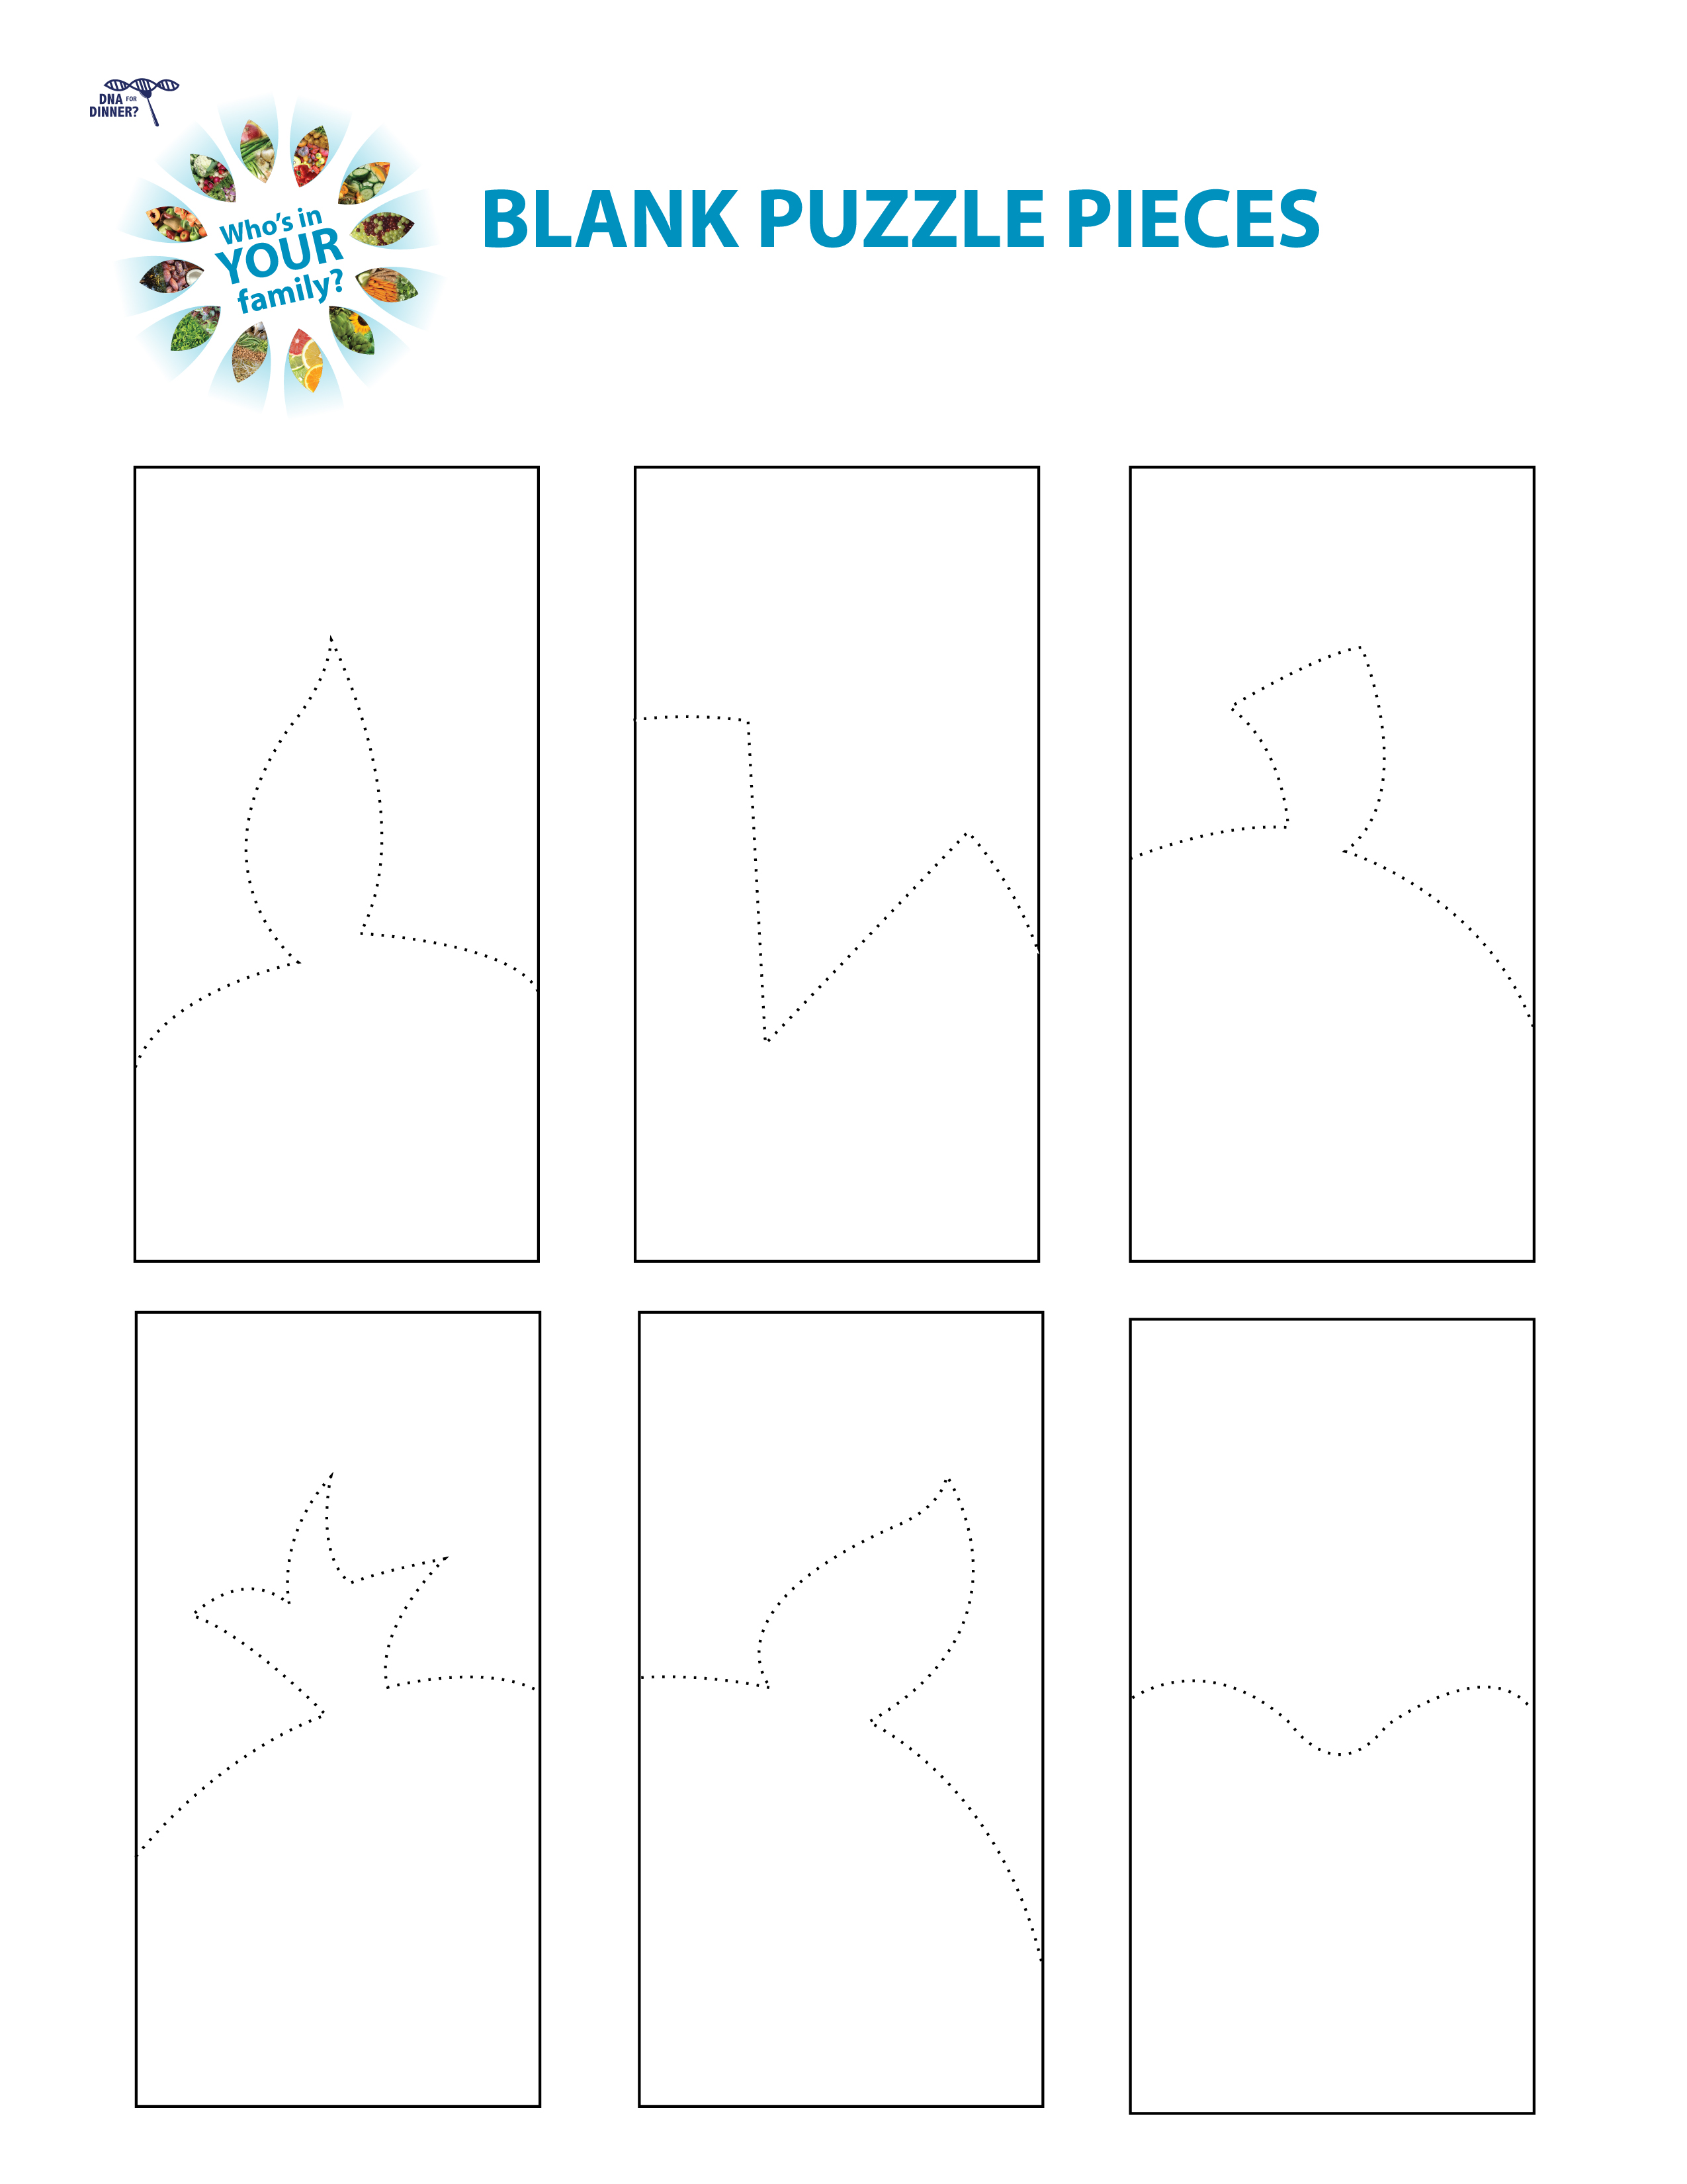
Create puzzle pieces using your own choice of fruits and vegetables!
Type in the name of the fruit/vegetable in the fields below.
To find out which fruits and vegetables are related, please visit http://ucbiotech.org/dnafordinner/lesson1/handout_1.2/index.html

Type name
Type name
Type name
Type name
Type name
Type name
Type name
Type name
Type name
Type name
Type name
Type name

